[Date]

New Mexico American Legion Riders Motorcycle Association
{NAME], Chapter Director
[Address]
[City], NM [Zip Code]
[Phone Number]

Dear Sir or Madam;

The American Legion was established under Congressional Charter as a national veteran’s organization for the purposes of supporting Veteran’s Affairs and Rehabilitation, promoting Americanism, ensuring National Security, and providing for the Children and Youth to ensure all had the necessary essential needs met. The American Legion has been established as an exempt organization under section 501(c)(19) which is recognized as a non-profit veteran’s organization.

The American Legion Riders Motorcycle Association was created as a program of the American Legion, in order to support veterans, veteran’s families, and veteran support organizations. The riders hold annual benefit drives to raise money for the Veterans and Children Foundation, Operation Wounded Warrior, and more.

We are asking you to consider making a donation of items or funds, to support these programs. Items may be used for auction or raffle purposes while 100% of your donations will go directly to the charity programs. There are absolutely no administration costs as we are 100% Volunteers.

Fundraising events are scheduled throughout the year. Your items can be used at any time that it is convenient for you to donate them.
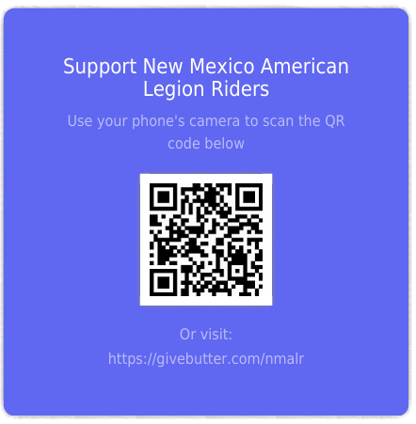
Your charitable tax-deductible donation can be sent to:
- a member representing our organization providing this letter.
- NMALR Chapter [Number], [Address].
OR
- Use your smart phone to scan the URL Code.

Sincerely,

[Signature]

